**Installing the Thermometer**

**The First Step: Connecting The Wires**

(*refer to the pin numbers in the back*)

First you will need 6 jumper wires, 3 being male to male and 3 being male to female. You will need 1 4.7k ohm resistor, the DS18b20 thermometer, a breadboard, and of course the Raspberry Pi.

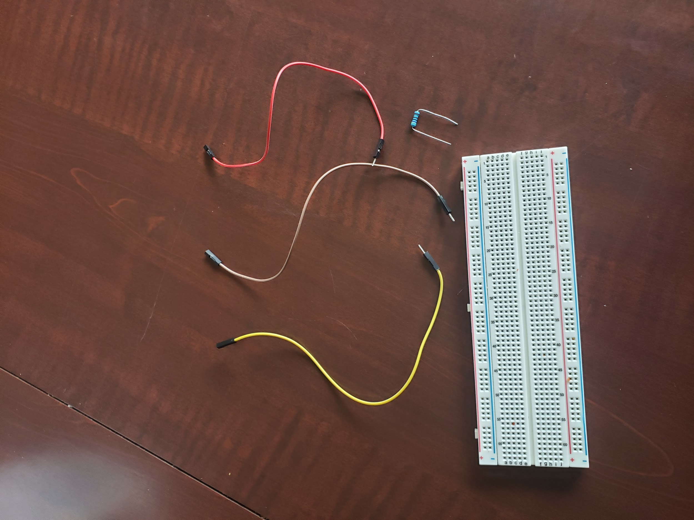

(just a few of the things you will need at first)

First plug three male to female jumper cables into the breadboard. One into a positive terminal, one into a negative terminal, and the last into a hole on the breadboard in any row. I chose row 6 for mine. You will then need to plug the resistor into the positive terminal remaining in the same section as the jumper cable. And put the other end of the resistor into the row with your third jumper wire.

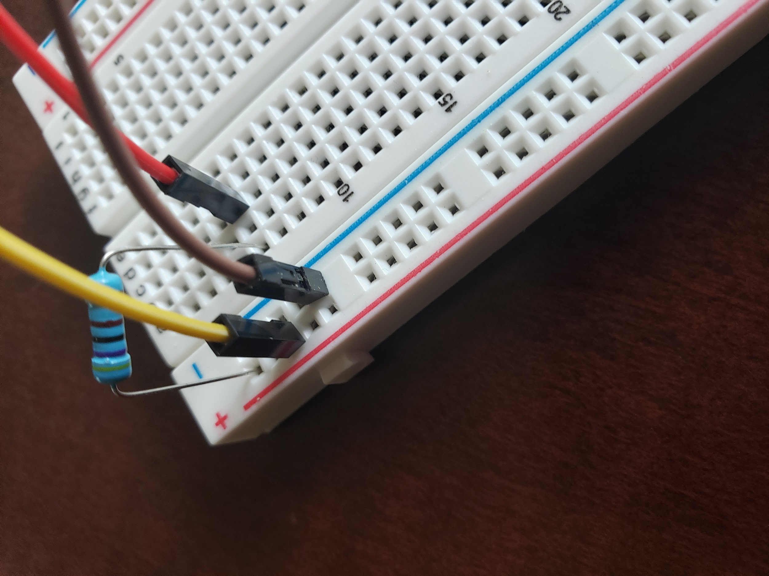

(this is what the first step should look like)

Next, take your three male to male jumper cables and plug one of them into a positive terminal in a section other than the ones used during the first step. Plug another into the negative terminal in the same section as the last, and lastly plug the third jumper into the same row as the resistor and the other jumper wire. Mine was row 6.

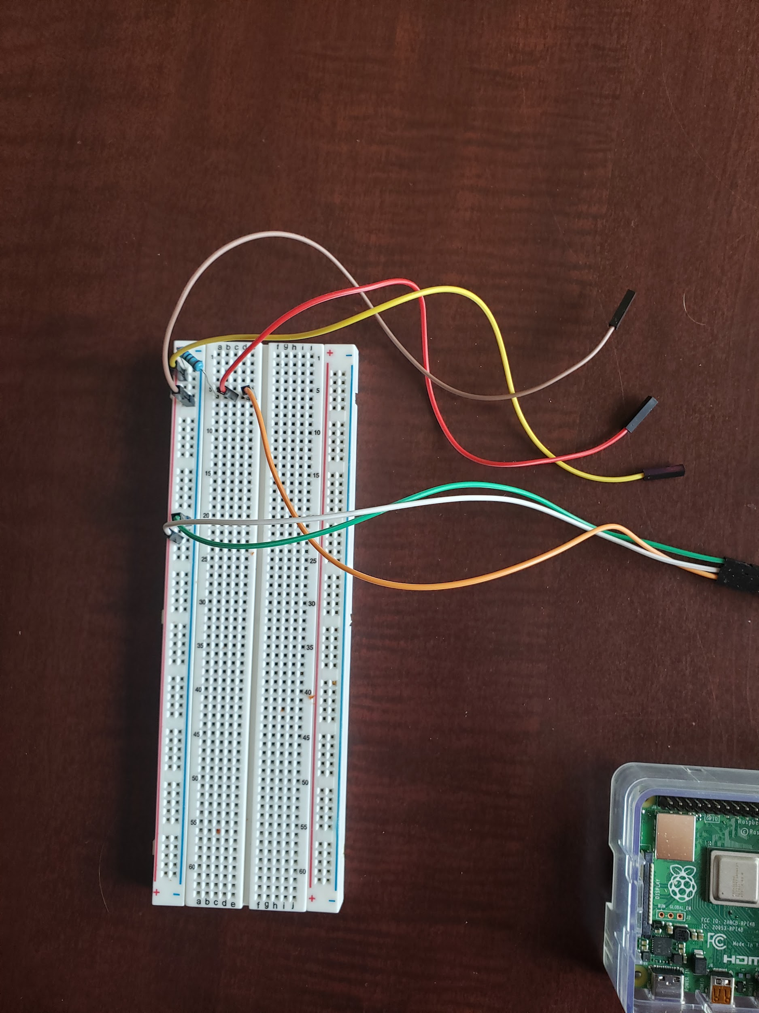

(what your breadboard should look like after step two)

The three male ends will be used for the thermometer, in my case the green was ground, white was Vcc, and orange was data. That means my green corresponds to black, white corresponds to red, and orange corresponds to yellow.

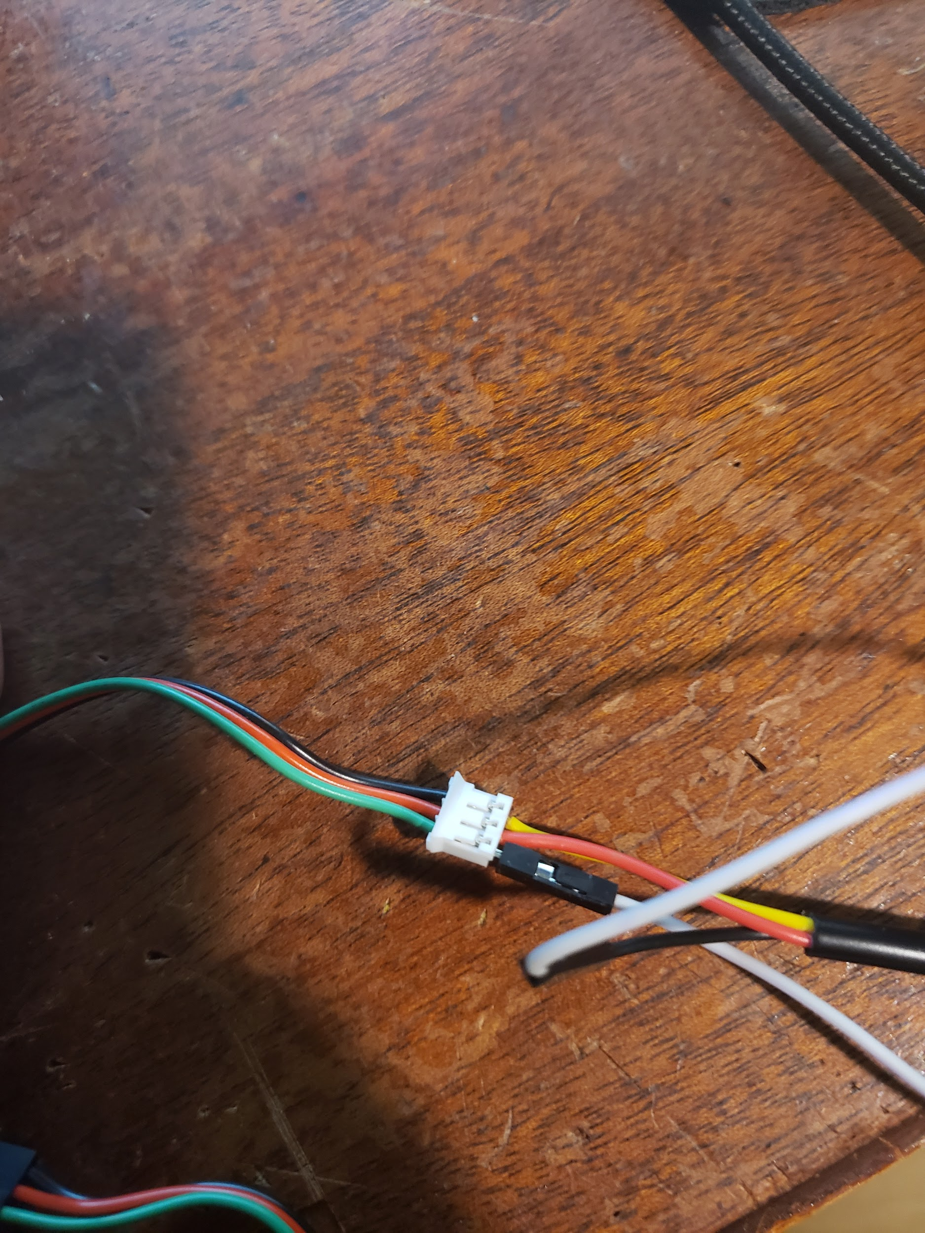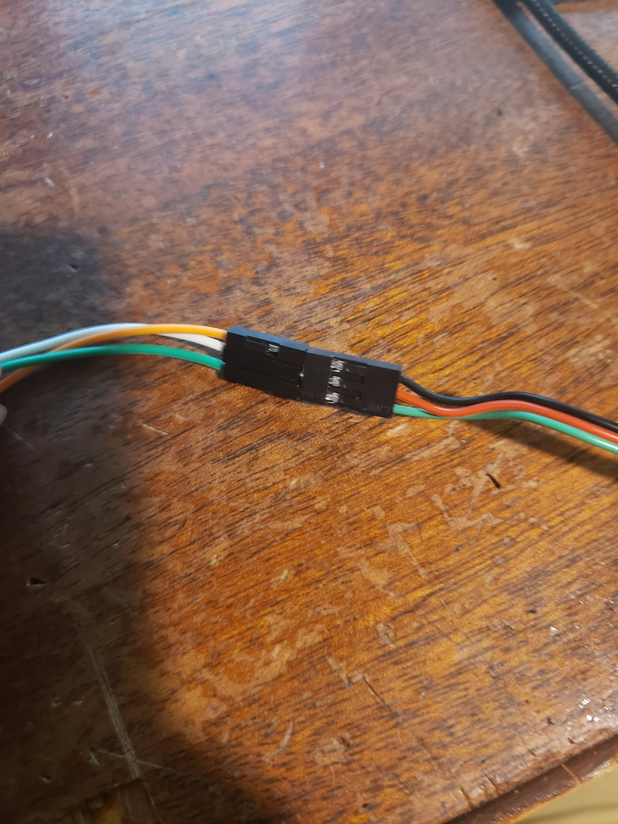

The first image is the thermometer attaching to the adapter, mine had a little mishap that’s why there is a jumper wire connected, the jumper wire is the ground wire. The second image is of the adapter connecting to the three male pins from the breadboard.

Next you will need to plug the three female ends into the Raspberry Pi. The pin connected to the positive terminal should be connected to pin 2, AKA a 5V pin. The pin in the negative terminal should be plugged into pin 6, AKA a ground pin. Lastly the pin connected into whatever row you have chosen, for me row 6, should be plugged into pin 7, AKA GPIO 4. A picture of which can be seen below. This concludes connecting the wires.

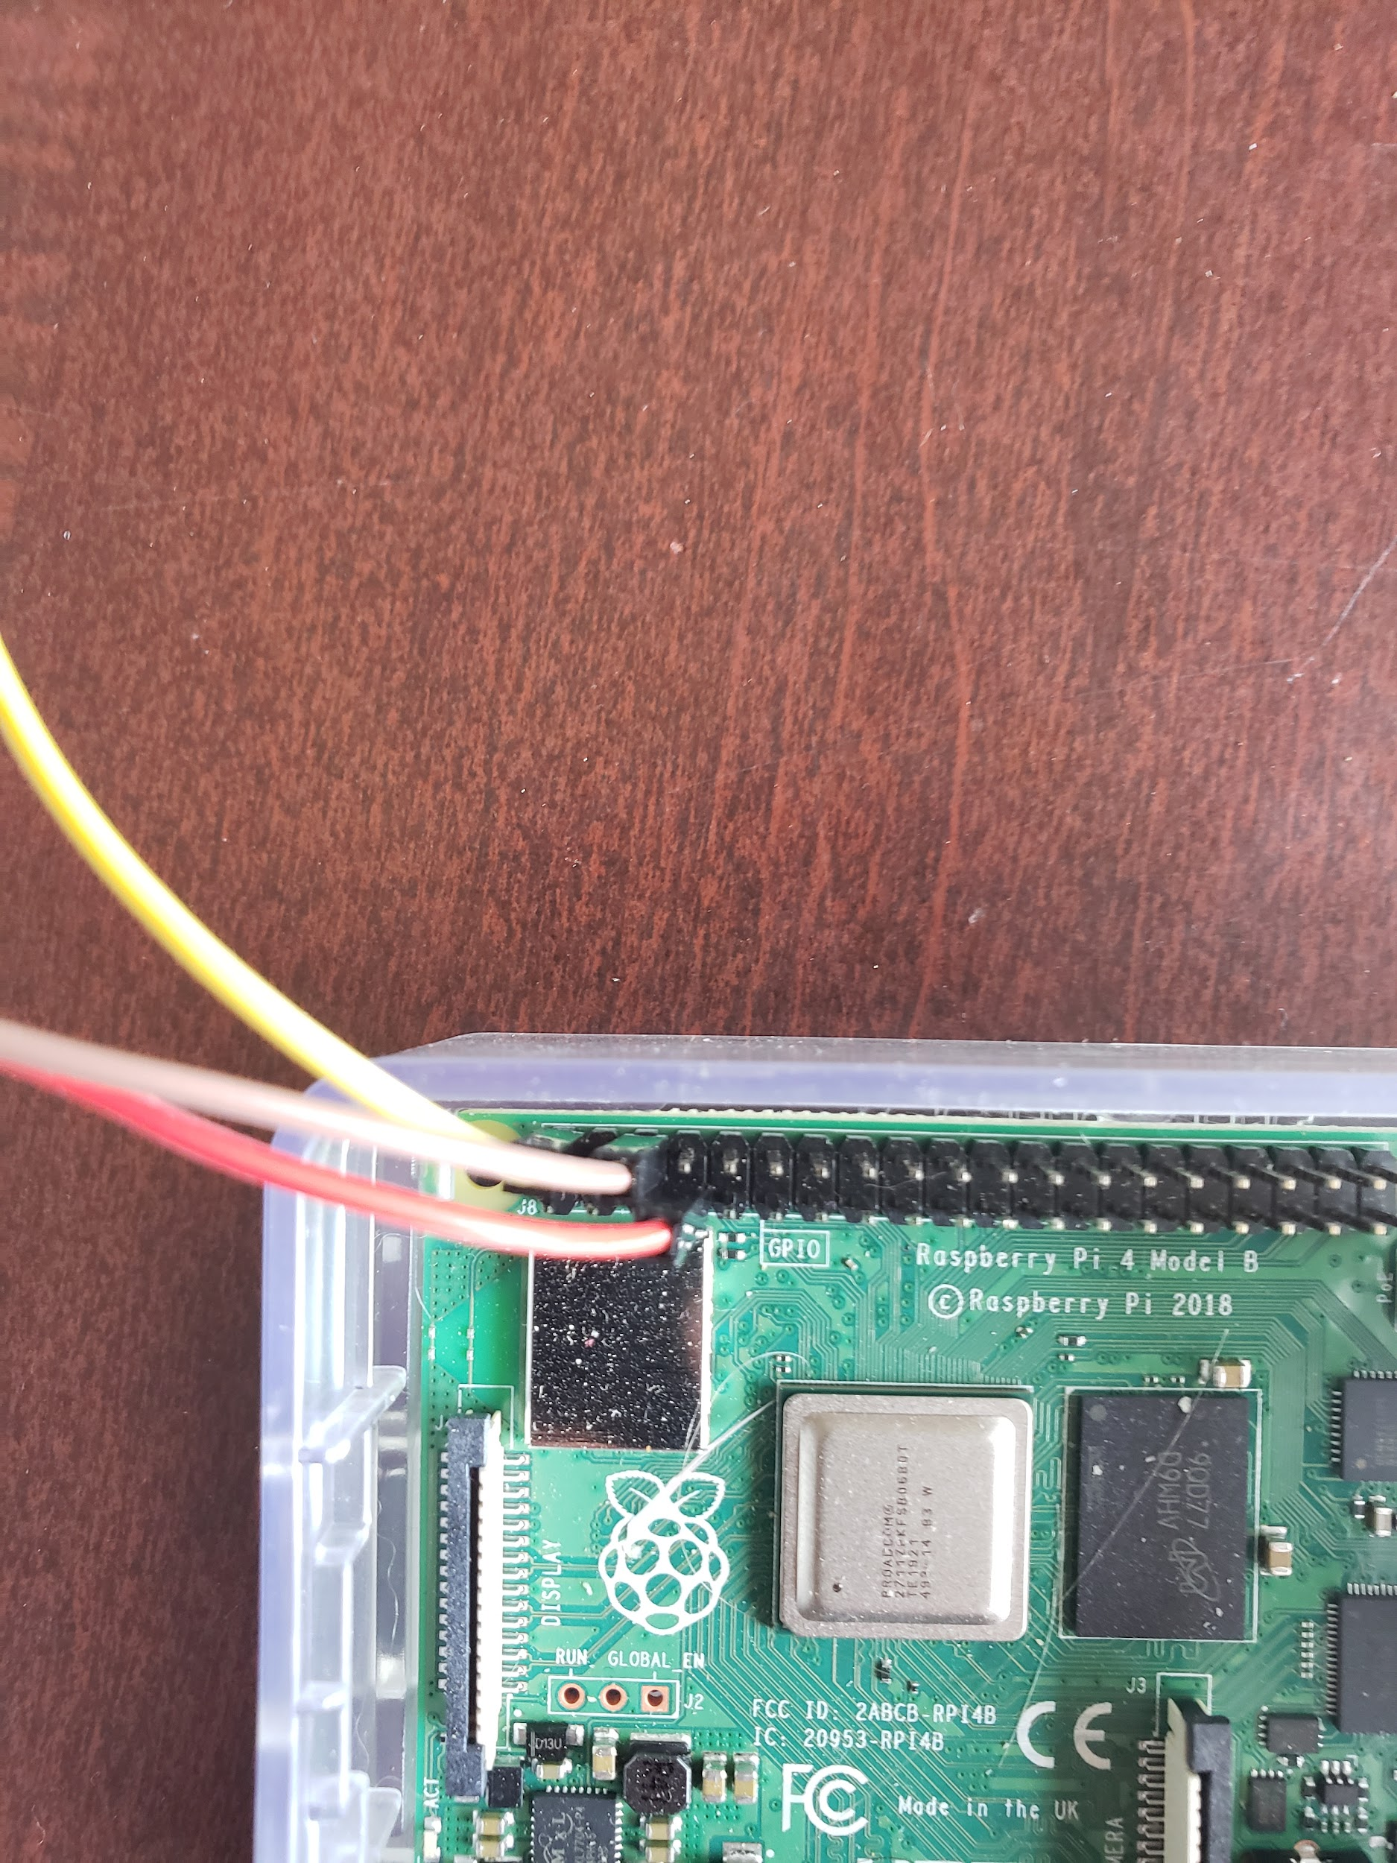

**The Second Step: Programming and Setting up the Software Side**

The first thing you need to do once all the cables have been connected is run a few commands on the command prompt on your Raspberry Pi. The first command is:

**sudo nano /boot/config.txt**

Once this has been typed you will be greeted by a wall of text. Scroll to the bottom and type: **dtoverlay=w1-gpio**

Then use ctrl-X to save the file and hit y to confirm. You will then need to reboot your machine. After that has been completed reopen the terminal and type:

**sudo modprobe w1-gpio**

After that you will want to type: **sudo modprobe w1-therm**

Everything should be ready now, but to be sure everything has been typed correctly, run the command: **cd /sys/bus/w1/devices/** and run **ls**

If everything works correctly you should see a serial number starting with 28- , if you do not see this, retry each step starting with the first command I told you to run and make sure everything is typed correctly.

Once everything is typed correctly you may begin programming, the ds18b20 supports connecting multiple sensors, so you will have to create a function to locate the serial number. I have included code to print out generic celsius and fahrenheit values.

import os

#finds the serial number

def sensor():

for i in os.listdir('/sys/bus/w1/devices'):

if i != 'w1_bus_master1':

ds18b20 = i

return ds18b20

#pulls the data off of the thermometer

def read(ds18b20):

location = '/sys/bus/w1/devices/' + ds18b20 + '/w1_slave'

tfile = open(location)

text = tfile.read()

tfile.close()

secondline = text.split("\n")[1]

temperaturedata = secondline.split(" ")[9]

temperature = float(temperaturedata[2:])

celsius = temperature / 1000

farenheit = (celsius * 1.8) + 32

return celsius, farenheit

def loop(ds18b20):

while True:

if read(ds18b20) != None:

print ("Current temperature : %0.3f C" % read(ds18b20)[0])

print ("Current temperature : %0.3f F" % read(ds18b20)[1])

def kill():

quit()

if __name__ == '__main__':

try:

serialNum = sensor()

loop(serialNum)

except KeyboardInterrupt:

kill()

**PINS**

